A Windows computer on the network has been infected with a piece trojan malware on the 27th Jun 2027 at 13:38 (UTC). This conclusion is subject of an analysis of packets & IDS alerts with further information from external research suggesting a webpage or downloaded file contained a malicious JavaScript(JS) file. The packet capture shows a download from ‘http://matied.com’, where a suspicious file has been downloaded, followed by 2 executable files(.exe) have been downloaded and the trojan malware call PUSHDO has been injected to the computer. As a result of this injection, a Snort & Suricata file was generated.

Within the PCAP file, the request shows where the external site supplied the malware alongside an internal DHCP request exposing the host:
Infected Computer
MAC Address | 00:15:c5:de:c7:3b
IP Address | 192.168.1.96
Host Name | FlashGordon-PC

Methodology
To investigate the logs to find the infected system, Wireshark was used to inspect the PCAP file with both Snort & Suricata files. Beginning in the Suricata file I found the 3rd entry captured an EXE file download. I took note of the destination IP Address to check the PCAP file in Wireshark
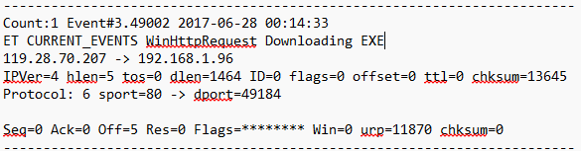
Within Wireshark I used these search terms to find this and the preceding events, revealing 2 GET requests where an exe file was returned. Upon further inspection, I found another malicious file.
Filter | Malicious files
ip.addr == 192.168.1.96 && http | trow.exe | wp.exe | gurv.gun
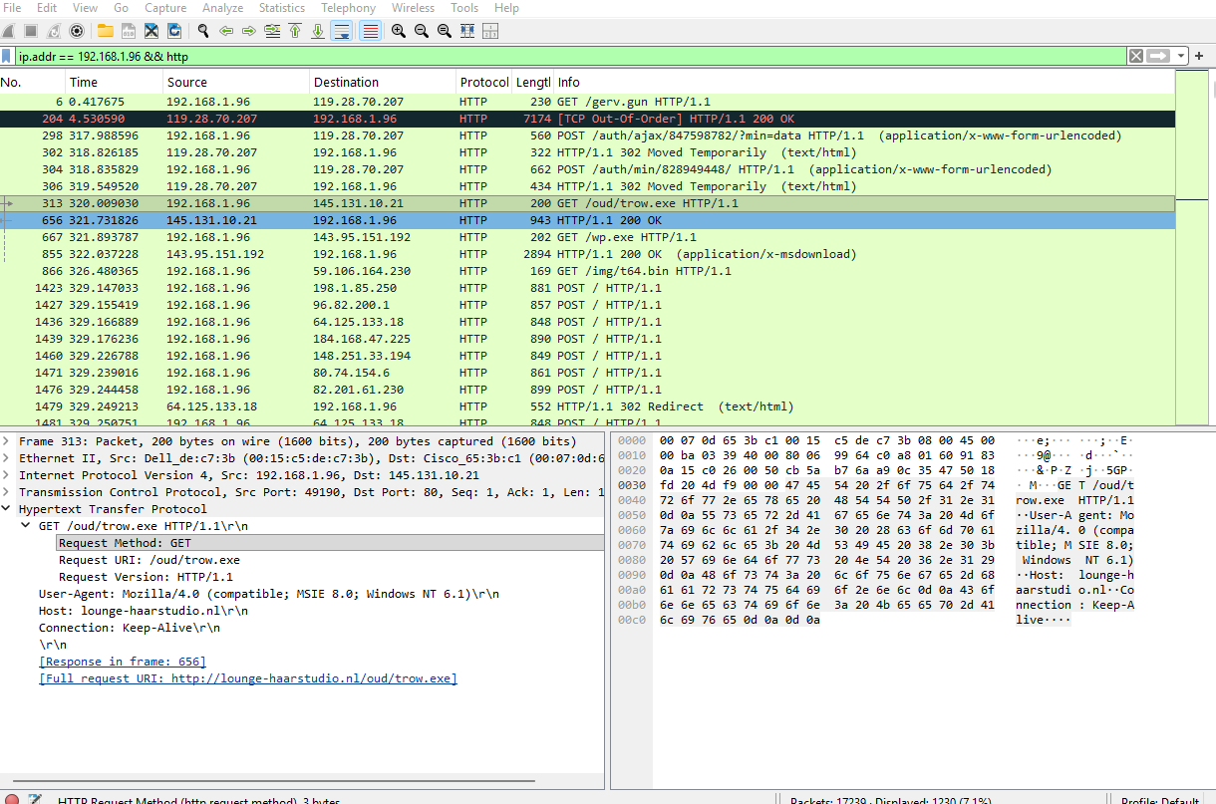
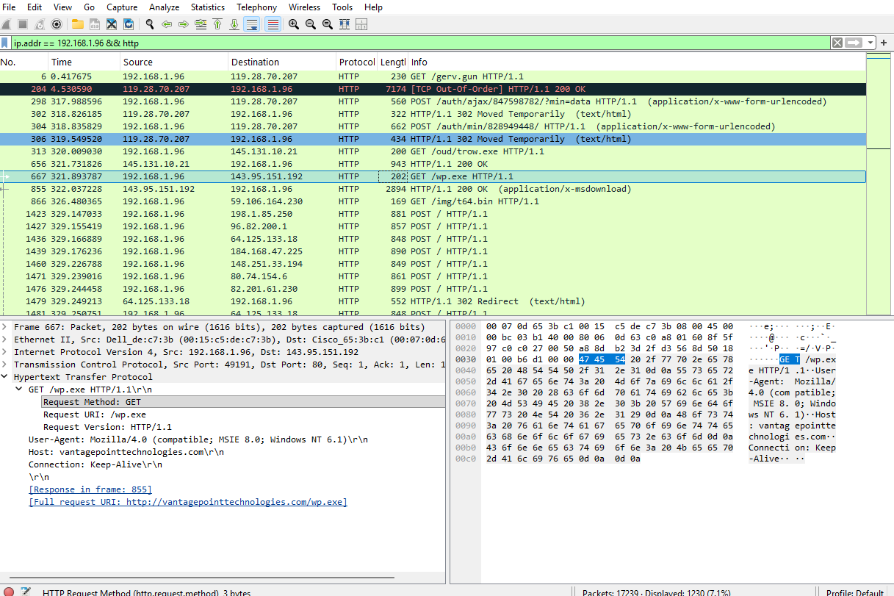
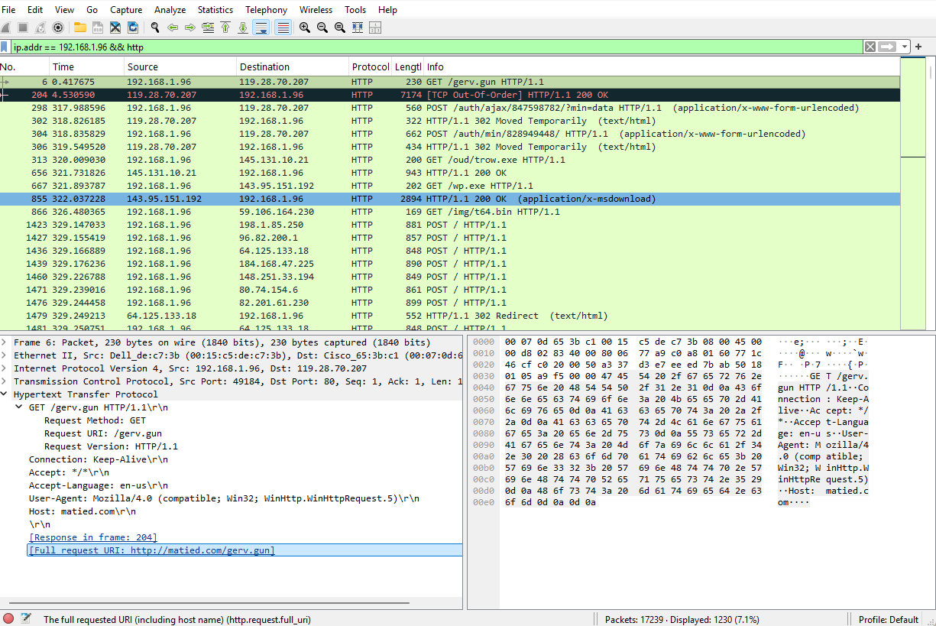

Date of Infection | 2017-06-27
Time of Infection | 13:38

Question | Answer
What was the computer infected with | PUSHDO
What was the Hash of the JS file infecting the computer | 59727ea201d94d471bdbb353b1281cca3c5bebf5305b140a3c017e52a37be702
Looking further into the Suricata file, I discovered the following. I confirmed this by inspecting the Snort file to find evidence to back up my claim that the computer was infected with PUSHDO.
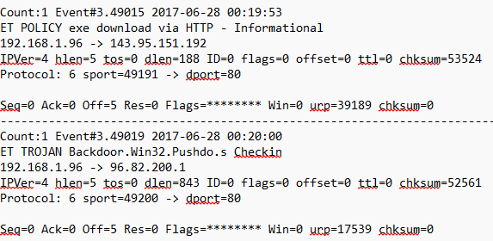
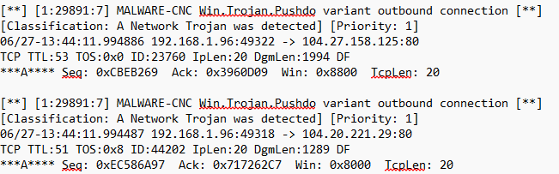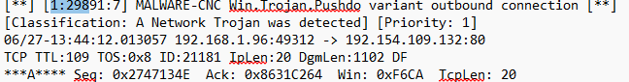

File | Hash
gurv.gun | 0931537889c35226d00ed26962ecacb140521394279eb2ade7e9d2afcf1a7272
wp.exe | 79d503165d32176842fe386d96c04fb70f6ce1c8a485837957849297e625ea48
trow.exe | 94a0a09ee6a21526ac34d41eabf4ba603e9a30c26e6a1dc072ff45749dfb1fe1

